**Online E-Health Care Management System**

**Deployment on Docker with Kubernetes**

E-Health Care Management System application mainly divided into three parts.

1. Database (My SQL)
2. Back end (Spring boot)
3. Front end (Angular Framework)

We will deploy all of these components on a Kubernetes cluster. We will have one replica of database, two replicas of back endand two replicas of front end*.*Front-end instances will communicate with back end through HTTP. Back-end instances will communicate with the database. To facilitate this communication, we have to configure Kubernetes accordingly.

We will configure the cluster by creating Kubernetes objects. These Kubernetes objects will contain the desired state of our deployment. Once these objects are persisted into the cluster state store, the internal architecture of Kubernetes will take necessary steps to ensure that the abstract state in the cluster state store is the same as the physical state of the cluster.

You have to create a *container image* of the application using Docker and upload it to *container registry* ie Docker hub.

A container image is a packaged form of the containerized application. It can be transferred across computers, just like any normal file.

Container registry is generally the centralized repository where container images are stored. One could upload container images to a container registry and download them wherever and whenever they are needed.

1. Create Dockerfile to run the angular application
2. Create Dockerfile to run the spring boot application
3. Create Dockerfile to run mysql database or official images to run the my sql image.

Configure PVC, service, and deployment for database

Configure service and deployment for back end

Configure service and deployment for front end

**High level View of the E-Health Care Management System**

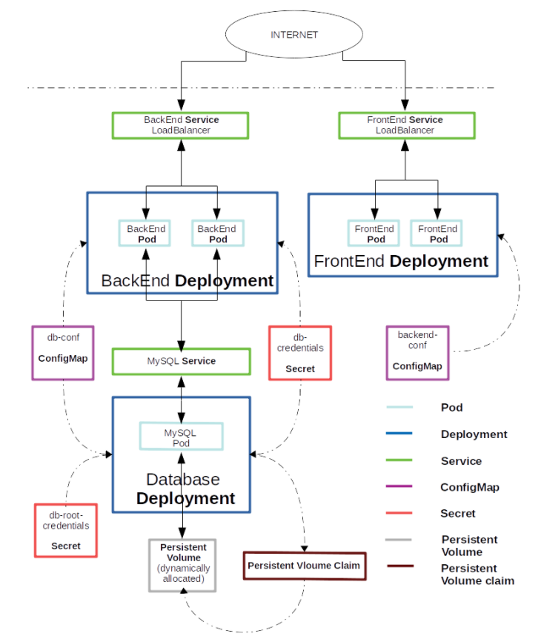

This high level diagram will help to deploy all these Docker images on Kubernetes environment.